**Startup Failure Post-Mortems 2019 Second Update (6/19/2019)**

### Anki

Title: [Robotics startup Anki shuts down after burning through almost $200 million](https://venturebeat.com/2019/04/29/robotics-startup-anki-shuts-down-after-burning-through-almost-200-million/)  
Title Link: <https://venturebeat.com/2019/04/29/robotics-startup-anki-shuts-down-after-burning-through-almost-200-million/>

Product: [Anki](https://www.cbinsights.com/company/anki)  
Product Link: <https://www.cbinsights.com/company/anki>

Consumer AI robotics company Anki had raised over $200M from prominent investors but the company wasn’t able to stay afloat after reportedly failing to attract a new round of investment or an acquirer. Anki posted a statement on its website:

It is with a heavy heart to inform you that Anki has ceased product development and we are no longer manufacturing robots. To our partners and customers, thank you for all your support and joining us on this journey to bring robotics and AI out of research labs and into your homes.

# Anki

INDUSTRIAL | Machinery & Equipment / Robotics

[anki.com](https://anki.com/)

## See what CB Insights has to offer

## Founded Year

2010

## Stage

Asset Sale | AssetsPurchased

## Total Raised

$205.26M

## About Anki

Anki is harnessing robotics and artificial intelligence (AI) to bring to life consumer products with intellect and interactive capabilities.

## Anki Headquarter Location

55 2nd Street 15th Floor

San Francisco, California, 94105,

United States

214-450-3701

Robotics startup Anki shuts down after burning through almost $200 million

Kyle Wiggers   
April 29, 2019 2:38 PM

Link: <https://venturebeat.com/2019/04/29/robotics-startup-anki-shuts-down-after-burning-through-almost-200-million/>

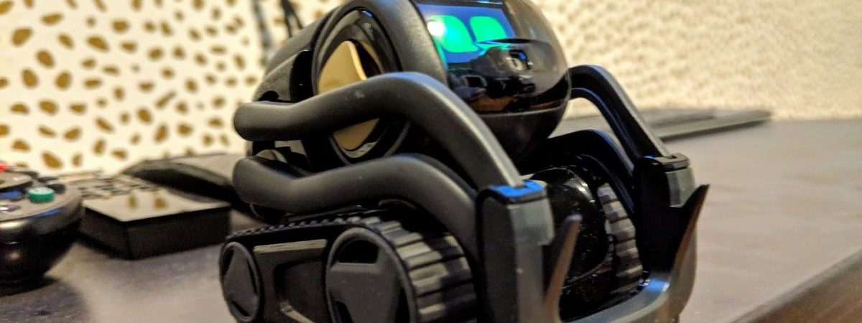

Anki's Vector robot. Image Credit: Kyle Wiggers / VentureBeat

[Anki](http://anki.com/), the San Francisco startup behind AI-imbued robotics toys like Overdrive, [Cozmo](https://venturebeat.com/2016/10/14/ankis-cozmo-robot-is-an-amazing-sentient-toy-but-the-novelty-may-wear-off/), and [Vector](https://venturebeat.com/2018/10/21/anki-vector-review-big-on-heart-not-on-smarts/), today [shuttered](https://www.recode.net/2019/4/29/18522966/anki-robot-cozmo-staff-layoffs-robotics-toys-boris-sofman) its doors after raising close to $200 million in venture capital from Index Ventures, Two Sigma Ventures, J.P. Morgan, Andreessen Horowitz, and other investors. According to [Recode](https://www.recode.net/2019/4/29/18522966/anki-robot-cozmo-staff-layoffs-robotics-toys-boris-sofman), it’ll lay off its entire workforce of just over 200 employees, each of whom will receive a week of severance.

A failed round of financing was reportedly to blame. CEO Boris Sofman told employees last week that a deal failed to materialize “at the last minute,” as did acquisition interest from companies such as Microsoft, Amazon, and Comcast.

Anki claimed to have sold 6.5 million devices total, and 1.5 million robots last August alone. (Cozmo was the top-selling toy on Amazon in 2017 with a community of more than 15,000 developers.) And in fall 2018, the company revealed that revenue was close to $100 million in 2017, a figure it expected to beat the subsequent year.

“Despite our past successes, we pursued every financial avenue to fund our future product development and expand on our platforms,” a company spokesperson told Recode. “[We were left] without significant funding to support a hardware and software business and bridge to our long-term product roadmap … We’re doing our best to take care of every single employee and their families, and our management team continues to explore all options available.”

Anki, which was founded by Mark Palatucci, Sofman, and Hanns Tappeiner in 2010 with the mission of “bring[ing] artificial intelligence and robotics into [users’] daily lives,” made a splash six years ago with its smartphone-controlled car set [Anki Drive](https://venturebeat.com/2015/09/16/anki-overdrive-is-a-kick-and-this-racing-set-shows-how-video-games-have-changed-toys/) (alternatively Anki Overdrive), which was demonstrated onstage at Apple’s 2013 WorldWide Developer Conference. Anki later became an Apple retail partner and introduced several Overdrive accessories, including a series with Hot Wheels branding.

Cozmo — a cute robot toy that made use of Anki’s company’s deep artificial intelligence research and team of Pixar and Dreamworks animators — debuted in October 2016, ahead of Vector. But despite their novelty and sophistication, the robots shared relatively high launch price points ($180 for Cozmo and $249 for Vector), which likely contributed to their slow uptake in the notoriously unforgiving consumer robotics space.

Anki’s closure follows the shuttering of Bosch-backed startup [Mayfield Robotics](https://techcrunch.com/2018/07/25/mayfield-robotics-ceases-production-of-kuri-robot-amid-a-questionable-future/), which was developing a larger, pricier ($700) home robot dubbed Kuri. Robotics company [Jibo](https://www.theverge.com/circuitbreaker/2019/3/4/18250104/jibo-social-robot-server-shutdown-offline-dead), which engineered a social robot featuring a bespoke conversational assistant, shut down earlier this year. In somewhat related news, industrial robotics company [Rethink Robotics](https://techcrunch.com/2018/10/04/rethink-robotics-closes-after-acquisition-plans-fall-through/) closed its doors seven months ago after attempting unsuccessfully to find an acquirer.